**Lab 3: Using EF Core CLI to Create and Apply Migrations**

1. Lab3-migration screenshot

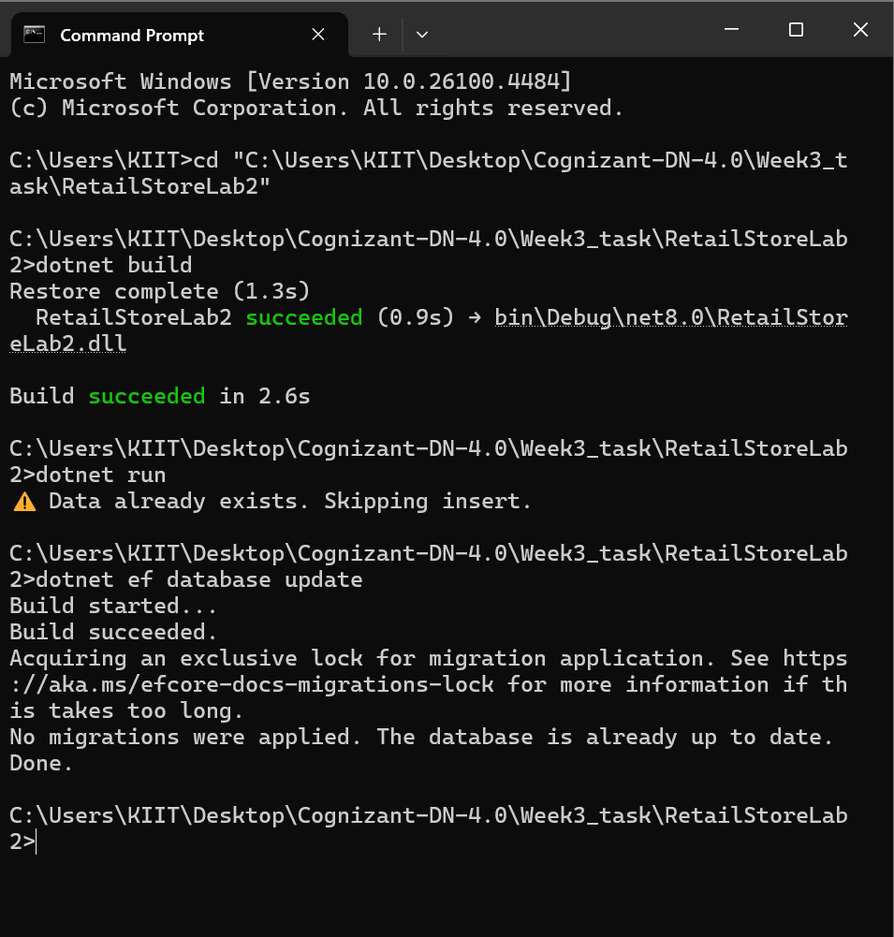

1. Lab3-Table creation screenshot

